Building a Community of Engineers: Platforms matter or dedication?

# ABSTRACT

Paste the appropriate copyright/license statement here. ACM now supports three different publication options:

* ACM copyright: ACM holds the copyright on the work. This is the historical approach.
* License: The author(s) retain copyright, but ACM receives an exclusive publication license.
* Open Access: The author(s) wish to pay for the work to be open access. The additional fee must be paid to ACM.

This text field is large enough to hold the appropriate release statement assuming it is single-spaced in Times New Roman 8-point font. Please do not change or modify the size of this text box.

Each submission will be assigned a DOI string to be included here.

This paper discusses the challenges on making effective community of engineers focusing on alumni-student relationship. It explores the dilemmas behind maintaining communication for building up a community of engineers which can provide both personal and professional care to those who seek for it, as well as excel the community performance in a better way. Though extensive research, it was found that, it is not always about the lack of a proper platform but lack of actual participation and dedication towards helping others that make such innovative ideas fail.

## Author Keywords

alumni; alumni student relationship; community of engineers; social psychology; web-based platform; professional expertise development; networking;

## ACM Classification Keywords

H.5.m. Information interfaces and presentation (e.g., HCI): Miscellaneous; See<http://acm.org/about/class/1998> for the full list of ACM classifiers. This section is required.

# INTRODUCTION

Building strong student-alumni community is highly beneficial for a society as well as the country [14] [15]. Through these communications, students get the chance to connect with professionals who were once in the same shoe. Students, through attending these mentoring programs or conferences, get the opportunity to talk about their desired career paths, any particular workplace, and insight views of the structure of a particular position of work, learn about the objectives beforehand and so on. The alumni community provides guidance, care, and confidence to the students [16]. In most cases, an alumnus wants to be connected to their alma mater, but can’t figure out how to effectively do so. Some attend 10 years or 20 years later reunions, where there is very little scope to flourish relationship with anyone new or reconnect with classmates.

Alumni are both national and international representatives of an institution [17]. It is found that, college students have the capability to captivate knowledge very quickly and at length but they lack the ability to share. Engaging the students in different courses or platforms designed to build up their communication/sharing capabilities to enrich their minds with innovative knowledge, is very important [1]

Educational Institutions can benefit immensely from a better understanding with their respective alumni community. From a mutual understanding, educational experiences for a student could be enhanced greatly by getting the support of alumni, who can help developing ways of the curricular and extracurricular activities being conducted which they were once appearing in. [2]

Everywhere we see people emphasizing on how important networking is for professionals specially engineering students, but there is rarely any talk of the importance of it for a student in general. It is a very crucial issue to be addressed as it can shape someone’s whole approach to professionalism. Today, networking doesn’t depend on time and space. Several social networking platform has had an immensely positive effect on it but due to the fear of being addicted towards it and disruption of your social life, parents and teachers do not appreciate these platforms. They simply don’t see it as a way of advancing oneself towards development, rather think of the harm it causes, which is, in many cases, proven to be true.

A research conducted by Spaeth and Greely stated that the further relationship with alumni on basis of their giving or participating in numerous circumstances directly depends on how emotionally attached they are with their alma mater and also depends greatly on the quality of the relationship over the years [9]

As mentioned earlier, no other network can be as effective for a student as talking to a respective alum who was once in the same position as them. Networking opportunities has a direct impact on a student’s career. Our focus is to examine the key importance and the barriers to build up a formal platform for the engineers of an institute. Through constant communication and effort to reach out to the alums from several fields, we explore the possible outcome of this initiative by providing a web platform, which is very easy to navigate and operate. Our key contributions are to explore different criteria that could possibly cause this idea to fail.

# Related Work

As this study focuses on the prominence of alumni-student relationship, how a student’s professional as well as personal life can be enriched and why without adequate enthusiasm or participation this initiative fails eventually, there needed some thorough research regarding the important aspects underlining alumni service.

During the undergraduate phase, most students find it very difficult in choosing the right direction which not only is suitable for them but also is in high demand. The surrounding environment teaches the choice of career is mostly based on perception of others as a recognized job. At the end every student dreams of having a working life which is respectful enough to carry on. This dilemma between what someone wants and what is asked to do, creates chaos.

Reportedly, CS Undergraduate students for example, can be very conflicted between how to make important course decisions, should one choose based on specific goals or from difficulty and demanding model [3]. Engineering students starts to comprehend exactly how important it is to have practical problem solving skills as well as the theoretical knowledge over the first five years in their respective job sectors [5]

Another dilemma faced by students is choosing the right career paths for them. Most of them don’t know about the potential career choices they have with the available skills in stock for them. Hewner and Guzdial, in a research, found that there are a lot of students unaware of any career choices besides working at google, they have difficult time to choose career paths that doesn’t have any programming tasks [4]

Linda Ott conducted an alumni assignment [7] that enabled students to know about career opportunities by contacting an alum, who are currently working in the same field the respective student desires to be associated with. Through the assignment, students not only learned from their role model about the pros and cons of their desired fields, but also got over the prejudice of having a subjective point of view towards career selection. Students’ final reports, which they got to explore for brainstorming their ideas; revealed a lot of diverse thinking, adaptive, creative approach towards job fields.

An extensive study conducted by Scott Garier gives a proper glimpse of the underlying factors. He analyzed 17 different variables to conclude what the main reasons are impacting the process of alumni giving and participation to their alma mater. It resulted in the academic variables becoming the most significant factors. There was a substantial increase in alumni giving and participation if it involved greater undergraduate academic experiences. The rate of alumni involvement increased with the level of positive academic experiences [10]

The different scenarios came out in some studies where alumni enthusiasm was missing at time of pulling up current students where they were in the best position to help. An interview results found by Kristen also notifies that although many participants are actively present in volunteering roles, but they do so when they find their own advantage underneath [11]

It was revealed in a study, that some non-donor alums of Midwestern University don’t define their student life as a lifelong association with their college. They think of college as a service which they paid for and has no obligation to give back furthermore. [12]

Alums are more likely to be members of an alumni association if they are current donors, had updated information in the university database, had positive experience before as an alumni, and were frequently associated with their alma mater [11]

The constant guidance and care of an alumnus throughout the first few years of entry level job makes a significant change in the success graph for a newly graduated student. Creating a strong community will not only help newly graduates but also it has the potential to prepare for the upcoming challenges more or less. An Alumni Association or community with proper and regular participation [6] can arrange different workshops, seminars, exhibitions which can potentially help all those associated with the association to a great extent and can benefit the parent organization immensely

To summarize, previous respective scholars from different fields have tried to highlight how confusing yet crucial education life can be and how associating with an alum can make a huge difference for successfully completing the process.

# Methodology

The primary objective of this research is to find out the challenges and opportunities to build an interactive community of engineers from the same institute. We have divided the method into two phases 1) How the students and alumnus for the same institute response to build an engineering community and 2) How they response in terms of enthusiasm if they are provided a platform. We have addressed the paradox focusing on formatting groups, effective communication methods, listing of functions and features that reflects someone’s personality, privacy issues concerning personal information and scalability. In the first phase of the research, we conducted both qualitative and quantitative approach with semi structured interviews and surveys. In the second phase, another survey was done on the alumnus group to measure their response.

## Establishing Communication

We established the primary communication via email, social networks and institutional existing groups with both of the current students and alumnus for the recruitment of our participants. To communicate with our participants we used snowball method, word of mouth and personal contacts. We clearly, explained our motivation behind this initiation, our goals and asked their contribution throughout the process.

## Building up Interest Groups

To justify our research question, we classified the interview sessions into two segment to see the before and after results of our proposition being executed, exactly how much enthusiasm people has for providing free counseling and help and how much students are aware of the importance of such platform. We advertised adequately through the institute’s current student groups, volunteers who responded to the email, and the listed alumnus’ from all around the world, including those currently working in the same institute, working in diversified engineering fields and working or studying in different countries. No monitory incentives were provided to any of the participants.

## Participants Recruitment

***Alumnus (n=12)***

For participant selection from alumnus, we maintained diversity among the alums. Apart from having both the genders be our equal participants, we included demographic factors: marital status, geography to make the study more consistent. Here, list of Alumni from the respected University, who were recruited for the interviews is in the following.

|  |  |
| --- | --- |
| Participant | Profile |
| p1 | Male; 2015 graduate; Major in Electronics and telecommunication (ETE); currently studying Photonics at Abbe School of Photonics; Former Lab Instructor at North South University; Former president of IEEE NSU Student Branch; currently residing in Germany; unmarried |
| p2 | Male; 2017 graduate;  Major in Electrical and Electronic Engineering(EEE);  currently working in EXIM Bank Bangladesh Limited as a Trainee Officer; unmarried |
| p3 | Female; 2017 graduate; Major in EEE; currently working at Ulkasemi Limited; residing in Bangladesh; unmarried |
| p4 | Female; 2017 graduate; Major in EEE; Teacher at Yale International School; Vocal and Keyboardist at Candle Carmine; Currently residing in Bangladesh; unmarried |
| p5 | Female; 2015 graduate; Major in CSE; Working as an Officer of Application Development at Save the Children in Bangladesh; Former lab instructor at North South University |
| p6 | Male; 2016 graduate; Major in CSE; Business entrepreneur; currently residing in Bangladesh; unmarried |
| p7 | Male; 2016 graduate; Major in EEE; Studying at Western Sydney University; Market Researcher at Micromex Research; Currently living in Australia; unmarried |
| p8 | Female; 2015 graduate; Teaching assistant at code camp; Studying in Western Sydney University; Residing in Australia; unmarried |
| p9 | Female; 2016 graduate; Major in EEE; Adjunct Faculty and Research assistant at Independent University, Bangladesh, Married, Residing in Bangladesh |
| p10 | Male; 2017 graduate; Major in EEE; Researcher at Tech Academy; Former Chair at Robotics and Automation Society, IEEE NSU Student Branch; Residing in Bangladesh; unmarried |
| p11 | Female; 2017 graduate;  Major in CSE, Former MIS Intern at  Pan Pacific Sonargaon, Dhaka Bangladesh; Living in Bangladesh; unmarried |

Table 1. List of participants from alumni community

## *Semi Structured focus group discussion (n=6)*

We recruited 6 current engineering students with equal number of both genders for the semi structured focus group discussion as we wanted to get their diversified data. They were also recruited through purposive selection, word of mouth and social network groups of the institute.

## *Survey for User Specific Demands (n=43)*

Before starting to build up the platform we prepared two survey forms, one for students, another for alums: filled with personal and professional question with which both the groups will be comfortable enough to elaborate on. For Alumni, we included questions about their current employment status and experiences related to present and past jobs, their surviving skills, how much involved they were with extra-curricular activities, privacy/security concerns with the shared data, in which areas they would like to help out, why such a platform is important from their point of view and more.

For students, we tried to get information about exactly what they are expecting from such a community. Why do they think such a platform is necessary, how do they involve themselves out from curricular studies, do they want direct or formal communication with the alums, how much help they have acquired from other communities and many more.

### **Data Collection**

The data collected for this research previewed us a general ideal of building such a community and how it will affect the future corresponding occasions regarding alumni as most of them are outside the country or unavailable due to occupation. We have conducted most interviews through skype, phone call and few in person.

# data analysis

To analyze different behaviors and structures of our proposition, we needed quantitative analysis as well as qualitative data which were collected through interviews. Through Survey, we analyzed a numerical representation in percentage to see the various demographic factors playing different roles in different people

Question 01: Alums were asked questions about their attachment with their alma mater through a simple 1 to 5 rating

We asked alums to simply rate their connectivity through a 1 to 5 rating system, resulting in a 50/50 scenario between moderate(3) and very high(5)


Figure 1. Alums responding to the question about connectivity with their alma mater

Question 02: We asked the alums to give us several reasons that could justify their non-involvement with their university

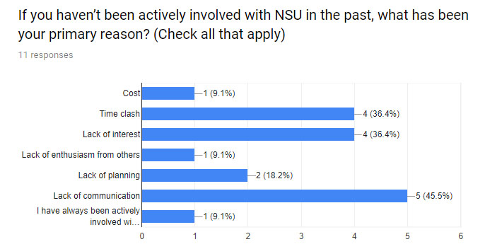

Figure 2. Alums responding to why they were not involved with their alma mater

Question 03: We asked Alums about the resources or services they would like to provide through the platform

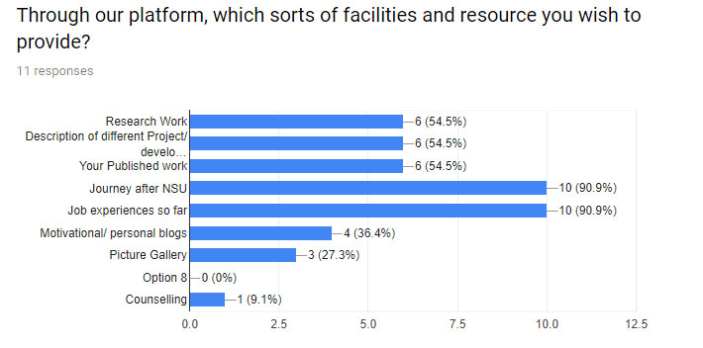

**Figure 3. Alumni talking about areas they want to contribute**

Question 04: We asked them about the key reasons behind the failure of making a community of engineers before

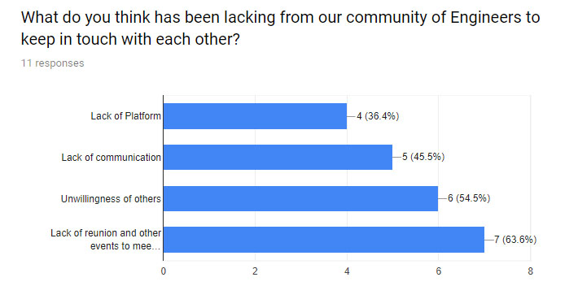

**Figure 4. Alumni answering why they failed to keep in touch with each other**

Question 05: We asked whom they’re comfortable with sharing the details about their Personal and Professional life

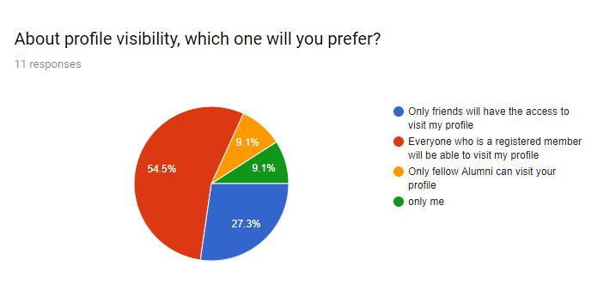

**Figure 5. Alumni talking about having a privacy option available in their profile**

While interviewing the alums, we wanted to know about their thoughts regarding this issue. We had to overcome time and space as almost all our participant alums are either outside of the country or are very busy with their job lives.

P6, who is an entrepreneur, graduated in 2017, Major in CSE, told us when asked about the initiative,

“ *I think it will be groundbreaking news if this works out, I am saying this because I have seen many attempts being failed overtime, I personally think that communication, you know, with people who are in the same pitch as I am, would be great! After university, friends are scattered all around the world, maybe this will reduce the obstacles*”

We further asked him about the areas is which he will be able to help,

“*As an Entrepreneur,* *I want to help engineers in developing their thought process of generating new ideas. Most engineers nowadays try their hardest to replicate something that is already developed. They try to take the easiest route and work on the simplest project to achieve the marks that they need, while learning mostly nothing new. That is wrong. Risk takers are always the winners, not just in business, but in engineering world too. So engineers should always try to make something unique, even when it can cost you project marks in the learning process. Grades can only ensure a job, but skills will earn you the pride, respect, and the future that you dreamt of”*

P5, graduated in 2015, currently working as an officer of Application Development at Save the Children in Bangladesh told us why does she think an alumni association for engineers is necessary,

*“It will be a very effective initiative if works out perfectly, Because Alumni community can guide the students about career, research and higher education. Current students can share their academic challenges so that alumni can pass the issues to respective authority. Both alumni and current students can collaborate and face any upcoming threat to NSU ECE* (*North South University, ECE Department*)”

P2, graduated in 2017, currently working in EXIM Bank Bangladesh Limited as a Trainee Officer, responded upon the question of why he thinks connection with alumni is important for students,

“*As an alumni, I believe that having the communication or any other sort if contacting option can be beneficial in the long run, because this would help us cement the parts of our gaps that we may face on the way forward*.”

P1,currently pursuing his M.sc in Photonics at Abbe School of Photonics, currently residing in Germany told us through a skype meeting about the security/privacy issues in sharing resources through the platform,

*“I think I will prefer showing my research work to students who are seeking knowledge in the subject. This a great initiative and I hope it becomes a reality”*

From the engineering student participants, we got the insights on the personality traits of alums which they would like to be informed about. Collecting the data from students was both a quantitative and descriptive analysis. We conducted a general survey and further formed a group for the focus group discussion.

We collected 43 responses through online survey, where the most important factors that we wanted to know are, 1) What type of method they will choose if they want to discuss about any personal and educational issues with any alum, 2) Through the community platform what sorts of facilities they expect and 3) What has been lacking from our community of Engineers to keep in touch with each other.

For the first question, around 60% students responded that they would prefer contacting the alumni by both email and direct communication. For the second question, 74% responses came as they want seminar and workshops from their alumni where 55% want to know their alumnus research profile.

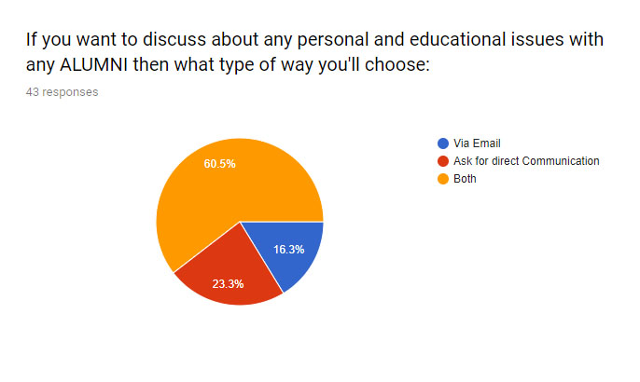

**Figure 6. Students talking about sharing their personal or educational issues with an alum**

For the third question that we emphasized on and which is the main motivation behind this research, around 74% responses came as they identify the lack of communication is the main obstacle to build a strong engineering community. While 65% thinks lack of proper knowledge of what actually the alumnus is working on is another important reason.

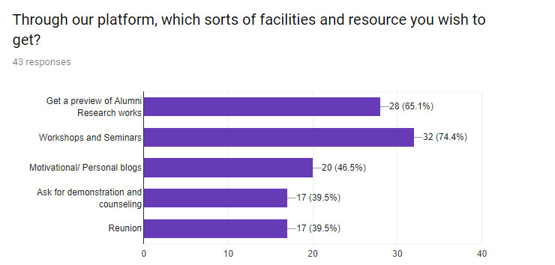

**Figure 7. Students talking about resources they would like to access of an alum**

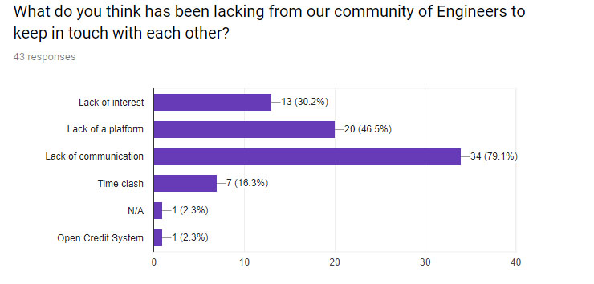

**Figure 8. Students saying what has been lacking to keep in touch with each other**

## Focused Group Interview:

A group of six, consisting of three female students who are in their 3rd year of university and three male students who are in their 3rd and 4th years, participated in the semi structured focused group discussion. Here, we have listed the prime questions and their responses accordingly.

Question 01- As a student, why do you think connection with your alumni society as well as current students is important?

|  |  |
| --- | --- |
| User 1 | “*As students, we are most of the times hopeless. Maybe if we could get some ideas about what to expect next in the most crucial phase of our education”* |
| User 2 | *“I will give you an example, most of the ideas I get I lose track of it at some point, Most of the times I am lost, a little help and motivation would be spectacular for me”* |
| User 3 | *“We get very little networking opportunities and I believe alumni community can be the best networks and also a lifelong mentor for us”* |
| User 4 | “*I think it will be helpful in order to know about the job facilities in the companies they work in, we will get to know the ups and downs of their lives”* |
| User 5 | *“I think alums can help us greatly in situations that they have faced earlier, they could help us choose the right courses and right direction in our desired paths”* |
| User 6 | *“It’s a great initiative, I would like to know about study, goals and job facilities”* |

Table 2. Group of students answering questions about the importance of an active alumni society

Question 02- In which areas you are seeking help?

|  |  |
| --- | --- |
| User 1 | “*I want to know about the ever changing professional world, job sectors”* |
| User 2 | *“I am looking forward to get many questions answered, I want to how do I cope with more credits/courses per semester, how do I prepare myself for the other side of educational life, the professional life, I want to know about the hobbies and talents of my superiors”* |
| User 3 | *“I am looking forward to studying abroad, I would like to know about all the experiences and procedures”* |
| User 6 | “*I want to enhance my professional skills and my senior brothers and sisters can help me with that”* |
| User 5 | *“I would like to seek help regarding my present situations, what courses to choose, which is in high demand, how to get a good grade”* |
| User 4 | *“I want to seek for a good gpa, so naturally would love to know the techniques of studying effectively, I don’t think I’ve got the hang of it clearly yet”* |

Table 2. Group of students stating about areas they seek help

# Designing a platform

From the analyzed data, we constructed a platform, in purpose to feed and nurture the relationship between alumni and students all around the world, building up a community which will bring diversified personalities all under one roof. We built a website similar to the functionalities of social media platform e.g. Facebook, but with a much formal approach as to conduct with seniors and fellow users. We kept in mind that this would only work if it has a welcoming design that makes our users feel like getting back to their university after a long time, which mostly applies for alums but we thought a design similar to our institute in terms of colors and focused activities would help the platform become successful.

## Features and Functions

There are three main actors playing connective roles in our proposed platform: Student, Alum, and Administrator. We decided to build up the platform in five phases. First, we implemented some common functionalities between the actors which can be regarded as a general base for any such platforms. Second, we implemented features and functions that would best define any personality with as much information as possible. Third, we addressed the privacy issue very seriously. Some sensitive cases where an alum is not particularly comfortable enough to share some work, for example with students, they can hide that from people at the beginning and change it later on if like. Fourth, implementing the possible services that can be provided by the platform. Fifth, defining the role administrator will play maintaining the whole system.

We named the platform NSUECEAA (NORTH SOUTH UNIVERSITY ECE ALUMNI ASSOCIATION). Few views of our platform for the department of Electrical and Computer Engineering (ECE), are given in the following.

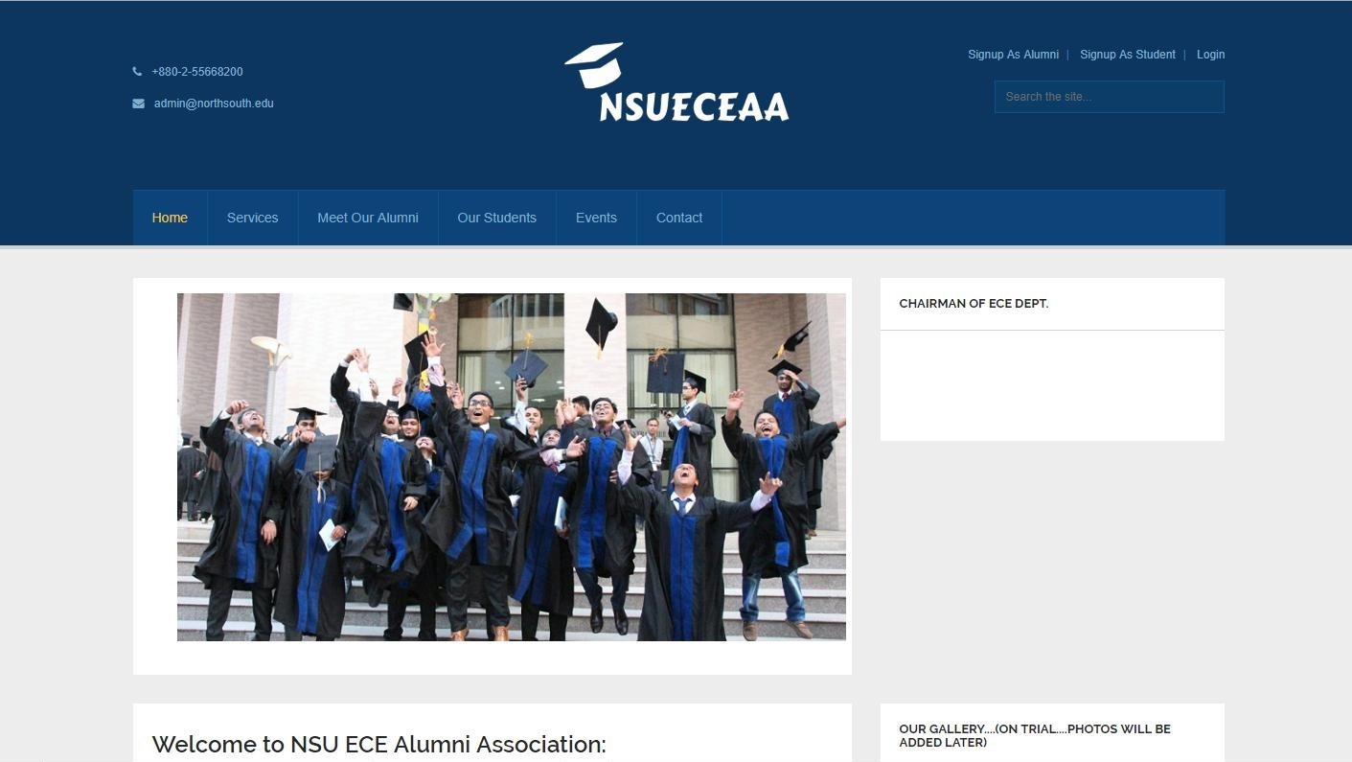

Figure 10. Home page of the community Website

## Users can update information about their current affiliation, their life story, Project and Research works, Travel diaries, Educational Background, Job offers, Achievements, Interesting facts, send and receive messeages

Figure 11. Features of user profile

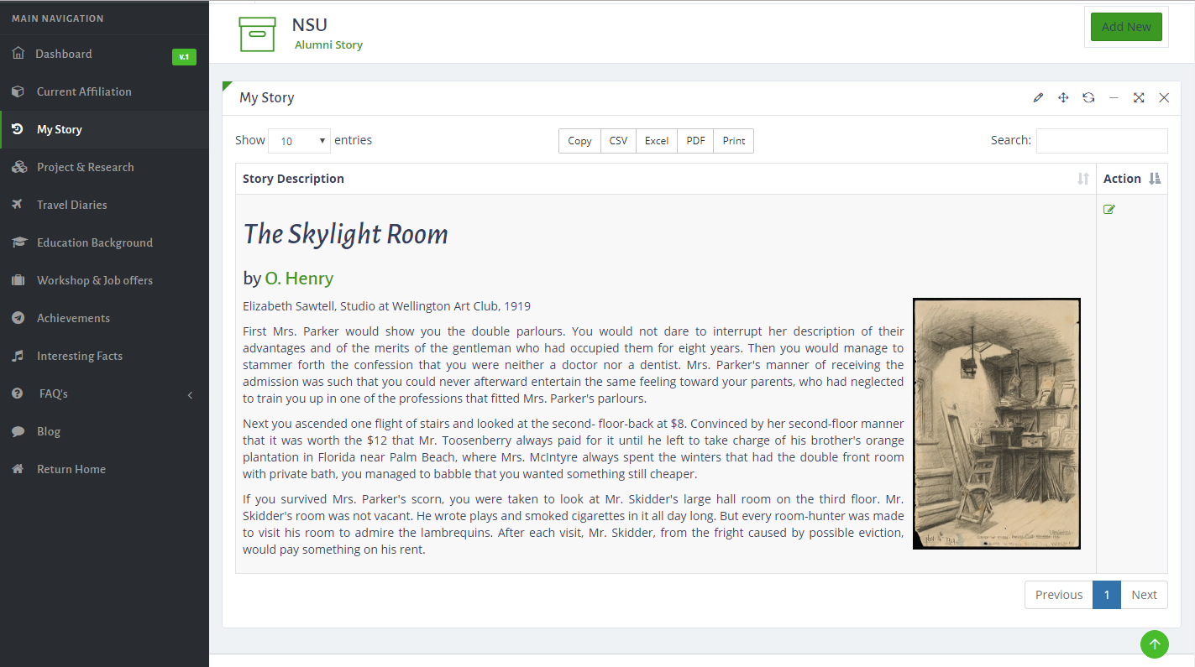

Figure 12. View of features

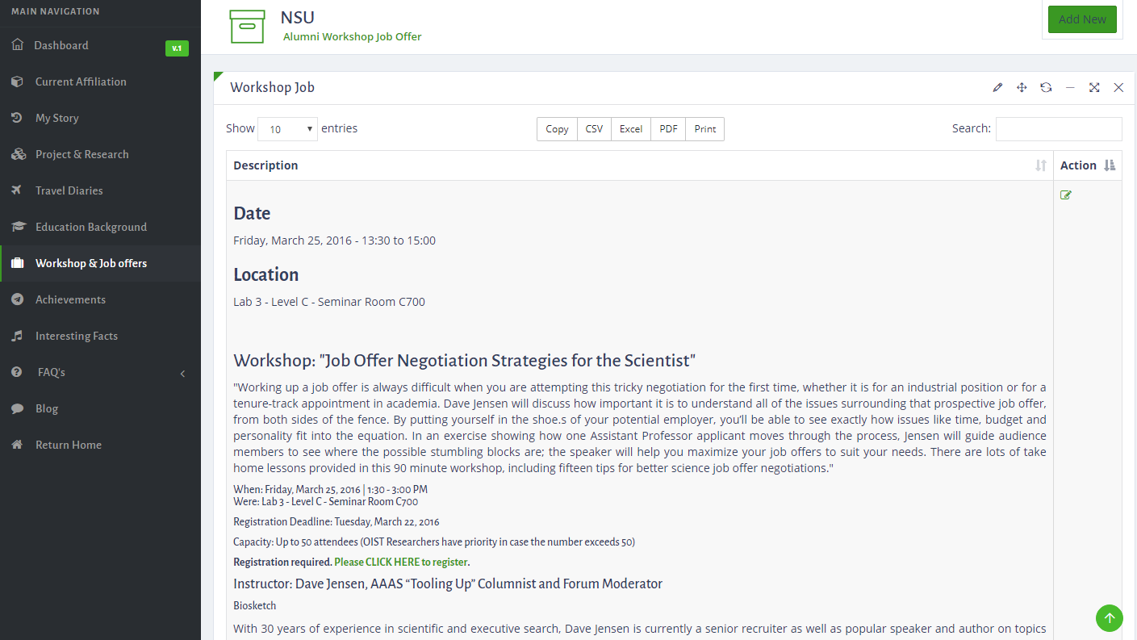

Figure 13. View of alumni offering job opportunities through the website

# Evaluation

Through Mark Zuckerberg’s Facebook, visualization of the dream of building up one common community among all the variance of the world, opened door to many other platforms [8]. He build a social media platform that went beyond time and space and now has a usability of 2.2 billion people worldwide. Similar to this idea and specified it to be a group of engineers who passed from the same university, has more or less many commonalities with the current student studying in their alma mater and likely so try building up a family. We tried to create a social media like platform but taking a rather formal approach towards it.

Upon conducting the first phase of our study, we worked to build up a platform for this focused community, but the reality was quite harsh with us. We got enormous support throughout the process, alums all around the world, who, not only motivated us but helped us with their extensive knowledge, but when it came to using the platform in real life, our initiative failed. Most of our alumnus didn’t participate in building up a community when there was an actual platform right in front of them.

We conducted second phase of our survey to learn about the reasons behind their absence among the same participants who participated in the phase one, where we tried to dig down the following issues, 1) If they have checked and used the platform at least once, where 63% answered positively, 2) Whom they want to help actually, 54% want to help only people whom they know or close to them and 3) What is the main reason of being absent from this platform, where most of them (81%) pointed as the lack of time. The results of this survey are enumerated as follow.

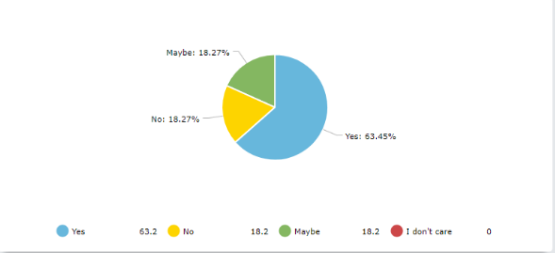

Figure 14. Alums answering about their usage of the platform

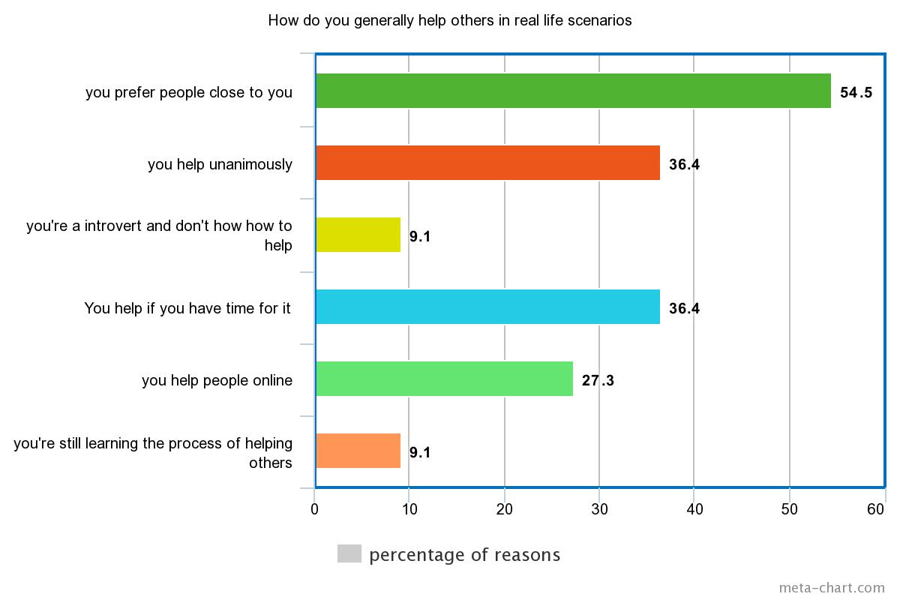Figure 15. Alums describing how and who they help on a daily basis

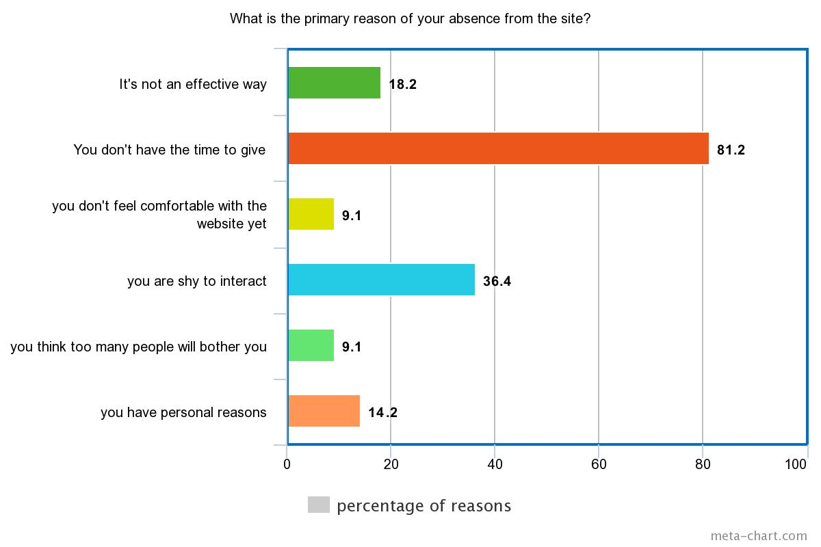

Figure 16. Alums stating the reason behind their absence

# Discussion

In the first phase of the research we focused on how the volunteering role can enhance the humanitarian support to students,

From the second phase of our research, a glimpse of the real world in terms of selfless care and help came out, where we realized it doesn’t come handy. Building up a dream platform was easy for us, but when it came to active participation to make the platform itself reachable, we failed. We tried finding some reasons but it all boiled down to one simple solution: dedication is the key towards making something remarkable. Here are some insights which could have led to its’ failure:

### **Negligence of Alumni as a Resource**

Universities have the potential to build a bridge between undergraduate and alumni by offering various internship or job opportunities, networking opportunities and set up events or programs to develop the communication between students and alums. Alumni community needs to have greater approach to maintain a long lasting relationship with their alma mater. Institutions should present opportunities to educate the students about the importance of organizational identification and alumni relations [11]. Our study clearly brings in the fact that alums are very willing to help but they may/may not have gotten the right amount of importance and respect that resulted in the distant behavior.

### **Misconception of Who Needs Help**

The misconception of alums that college/university is not needy was brought out by M Linda Wastyn [12]. In this study, participants don’t think of philanthropic service towards their alma mater as an important matter. If a problem is not highlighted enough, mostly it is neglected. We believe this is one of the reasons of failure.

### **Time Management**

One of our alumni participants P1, during the interview, answered the question: Would you like to interact with others through the website on a regular basis?

*“I am quite busy right now with personal and professional work, I will try to check the messages once a week”*

Response from another participant, P2 was,

*“I am not sure about regular basis, this would hugely depend on whether I’ve time or not”*

In order to make any innovative ideas succeed, be it a business model, a charitable organization or an alumni association, active participation is much needed. Life is a challenging path through and through for everyone, but giving a little time to something that could turn into a meaningful way of building up a helping community, could have helped our dream become reality.

## Opportunities to build better network

From the participants’ interviews some possibilities that came up to reform the approach which can be considered as the remedy to the current situations.

### **Fund-Raising Programs**

In order to effectively engage the alums to support their alma mater, fund raising programs need extensive reach [12]. Fund raising programs could give financial support to those who need it and can also be contributed as potential investments towards various welfare activities for an institution

### **In Campus Activities**

Alumni should regard giving back to their alma mater, more specifically to their respective departments as a duty, because it is the department/teachers’ dedication and care that made them who they are now. Universities could create a strong bond between alums and students by organizing various mentoring programs, reunions, workshops and tech talks. Reunion of a particular batch of a department should be extended as Alumni-Student meetup programs, where there are plenty of opportunity to build up connections.

### **Off Campus Activities**

Inside the campus corridor things remain always a bit formal and mundane, off campus activities brings in the fun side of building up relationships. Casual meetups, Tours and get together once in a while could help reducing the distance. The most important way, which is fun as well as rewarding is the lively hand in hand participation of alumni and students in different social and cultural welfare activities. Members of DGT Alumni Association formed the DGT Foundation for charitable activities and to give back to the development of students. [13]

### **Sustain the Relationship**

Several demographic changes in the lives of the alums could hamper sustaining a long lasting relationship. Universities has to realize that alumni are one of the greatest resources not only to their current students but also for the international recognition and welfare activities.

### **Dedication and Determination**

The participants in our study have been generous enough to give us their time to collect the necessary data analysis. Seeing the participation rate being low in spite of having ready and resourceful platform, it makes us wonder, does this matter completely in the positive academic experiences or Strength of determination. We dedicate our time bettering ourselves throughout our lives, why not help others too while doing so?

# Conclusion

This study explores the possibility of building up a community of engineers with ideologies and values of uplifting each other when needed. The whole idea would be a failure if there is no collective effort to take care of it. Universities should work relentlessly upon developing and maintaining relationship with its alumni. The focus was never to just helping students, but helping all that concerns. Alumni society are scattered all around the world after graduation, it’s hard to battle with time and geography when there is no real effort. Alumni could mentor students, keep in touch with each other, highlight their university at a national/international platform and do so much more together as a creative family.

We saw that, agreed participants in our study were more than enthusiastic and keen to be a part of this, but saying something and actually doing it has a vast difference. The motivation and emotional support goes in vain if efforts are not made to succeed an initiative.

One of our participant, P4 during an interview,

“*Most of the alumni of the Engineering department are involved in research and development and you can build a huge resource if you can properly utilize this site, I can help mentoring students who are new to world of application development as I am currently working as an officer of that department*.”

The importance of constructing a growing and cordial relationship with the alumni society is evident throughout the study. For alumni, they should bear in mind the importance of the connection with the alma mater. An effort from both institution and alumni can help achieve the goal to build a successful community which can sustain further.

# REFERENCES

1. Wang Lin, Luo Dongying, Shi Haizhang and Liu Mengying(2017); A Comparative Study On The Interpersonal Network Of Learning Promotion And Employment Competitiveness; 2017 *First International Conference on Electronics Instrumentation & Information Systems (EIIS);* https://doi.org/10.1109/EIIS.2017.8298557
2. Neil Rubens; Martha Russell; Rafael Perez; Jukka Huhtamäki; Kaisa Still; Dain Kaplan; Toshio Okamoto 2011; Alumni network analysis*; IEEE Global Engineering Education Conference (EDUCON*); https://doi.org/10.1109/EDUCON.2011.5773200
3. Winters, K. E., et al, 2013, “From Freshman Engineering Students to practicing Professionals: Changes in Beliefs about Important Skills over Time.” Presented at *120th ASEE Annual Conference & Exposition, Atlanta, GA*,
4. Michael Hewner and Mark Guzdial. 2011. How CS majors select a specialization. *In Proceedings of the seventh international workshop on computing education research (ICER '11)*. ACM, New York, NY, USA, 11-18. DOI=10.1145/2016911.2016916 http://doi.acm.org/10.1145/2016911.2016916
5. K Sivaprasad, 2012Making Best Use of Alumni Associations for Holistic Development of Engineering Institutes, *IEEE International Conference on Engineering Education: Innovative Practices and Future Trends (AICERA),* 19-21 July 2012; https://doi.org/10.1109/AICERA.2012.6306687
6. Faulkner, W., “Nuts and Bolts and People's Gender-Troubled Engineering Identities,” *in Social studies of science*, vol. 37(3), pp. 331-356, 2007
7. Linda Ott, 2015,Alumni as a resource to increase student retention in early computer science courses; *Frontiers in Education Conference (FIE)*, 2015 IEEE, 21-24 Oct. https://doi.org/10.1109/FIE.2015.7344025
8. Facebook, From Wikipedia, the free Encyclopedia, https://en.wikipedia.org/wiki/Facebook
9. J. L. Spaeth and A. M. Greeley (1970), Recent Alumni and Higher Education: A Survey of College Graduates, McGraw-Hill, New York
10. Gaier. S, 2005, Alumni satisfaction with their undergraduate academic experience and the impact on alumni giving and participation, *International Journal of Educational Advancement*, vol. 5 No. 4, 279-288
11. Etzelmueller, Kristen L. (2014), "Organizational Identifcation in Alumni Relations" College of Professional Studies Professional Projects, Paper 71, Marquete University, https://epublications.marquette.edu/cps_professional/71/
12. Wastyn, M. Int J Educ Adv (2009) 9: 96, Why alumni don’t give: A qualitative study of what motivates non-donors to higher education <https://doi.org/10.1057/ijea.2009.31>
13. DGT foundation, created and maintained by DGT Alumni Association, retrieved from <http://www.dgtaa.org/foundation/>
14. A. A. (Braam) Rust and C. S. (Corrie) Uys (2014), The Importance of a University Identity for Students and Alumni: The Case of the Cape Peninsula University of Technology, South Africa, *Journal of Social Science*, 40(1): 29-40
15. Radcliffe, S. (2011), A study of alumni engagement and its relationship to giving behaviors, Master’s Theses, Bucknell University, [online at]: <http://digitalcommons.bucknell.edu/masters_theses/2>
16. Volin, Joseph. The relationship between undergraduate student involvement and subsequent alumni engagement, Northern Illinois University, ProQuest Dissertations, 2016. 10158940
17. Trowler, Vicki. "Student engagement literature review." The higher education academy 11 (2010): 1-15.